Assignment 2

1)

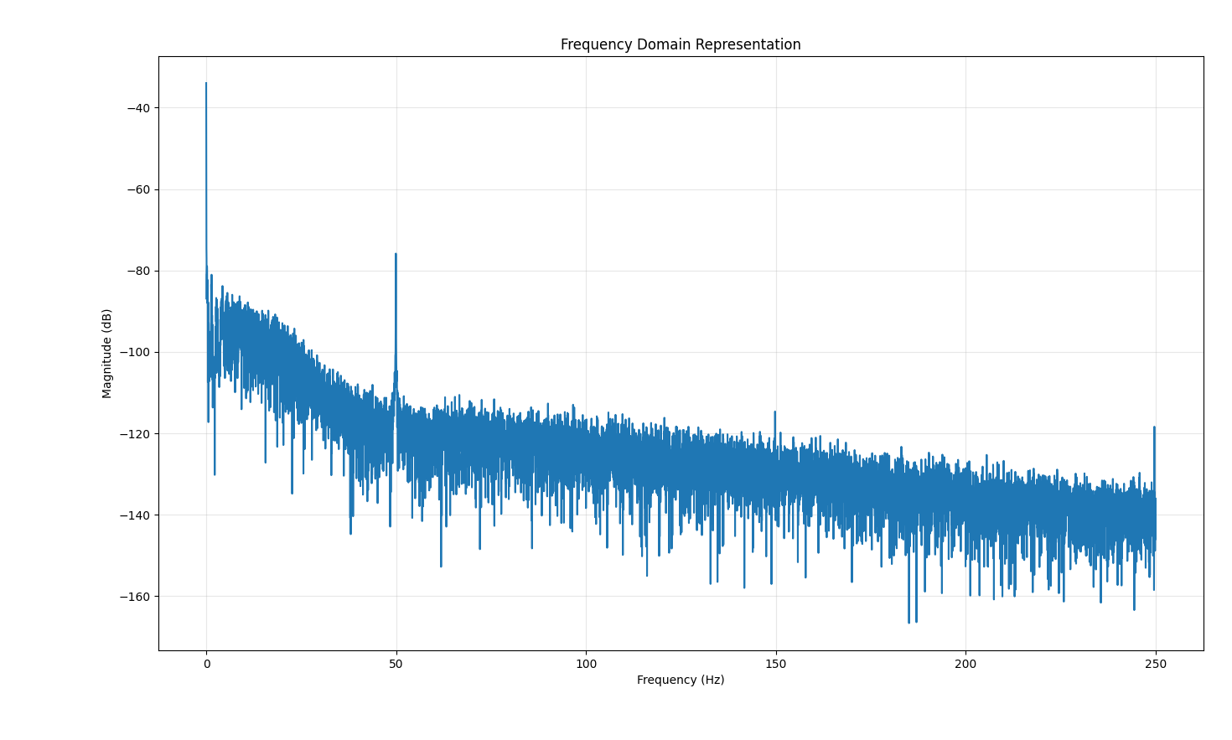

Shown above is the frequency spectrum of the raw heartbeat signal. As can be seen, there is a strong DC component (circled in yellow), and a lot of noise at 50 Hz (circled in red). To counter this, we removed frequencies below 0.4 Hz, since we expected the heartbeat to be between 0.8 Hz and 1.5 Hz, and we removed frequencies between 45 and 55 Hz.

